

**Mentor**

### Who is the mentor:

The Mentor is chosen to track the member and learner activities. Mentor has to give each Member and Learner their tasks and check if they successfully completed their share of work and guide them as needed. They have to get a weekly report from Members and Learners and give a brief report to the supervisor as well.

In addition to all this, they can help with main tasks such as coding and writing the paper.

### What does mentor need after logging in:

* Complete your profile
* Choose your Experience Badges
* Go through the projects and find the ones that you find interesting
* Increase in your credit
* Apply for the projects
* Sign the contract
* Check the meeting time
* Check tasks that assign from supervisor

### What does mentor need after logging in:

### **Complete your profile**

Everybody can register in the site through “Join Us” bottom, as follows:



Then, If you are signing up as an individual

person, please select “**Individual”** and fill

out the form as follows:

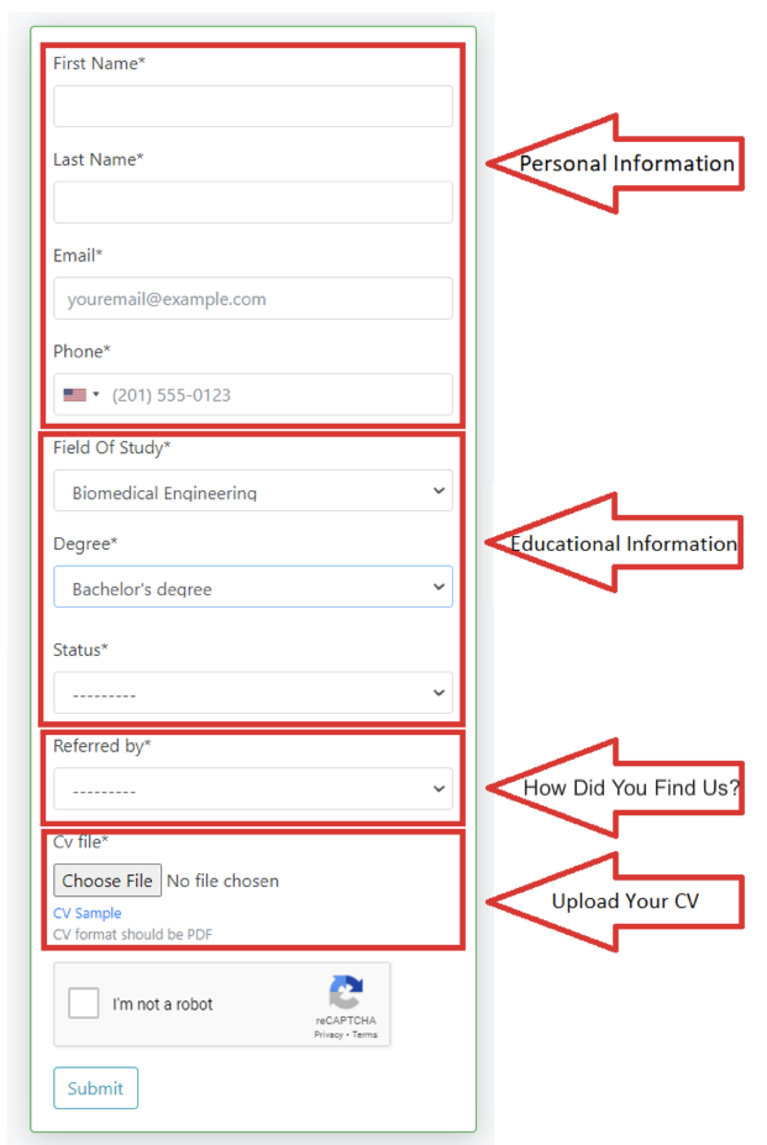

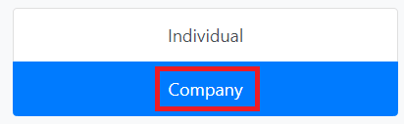If you are signing up as a company, please

select “**Company”** and complete the form as

follows:

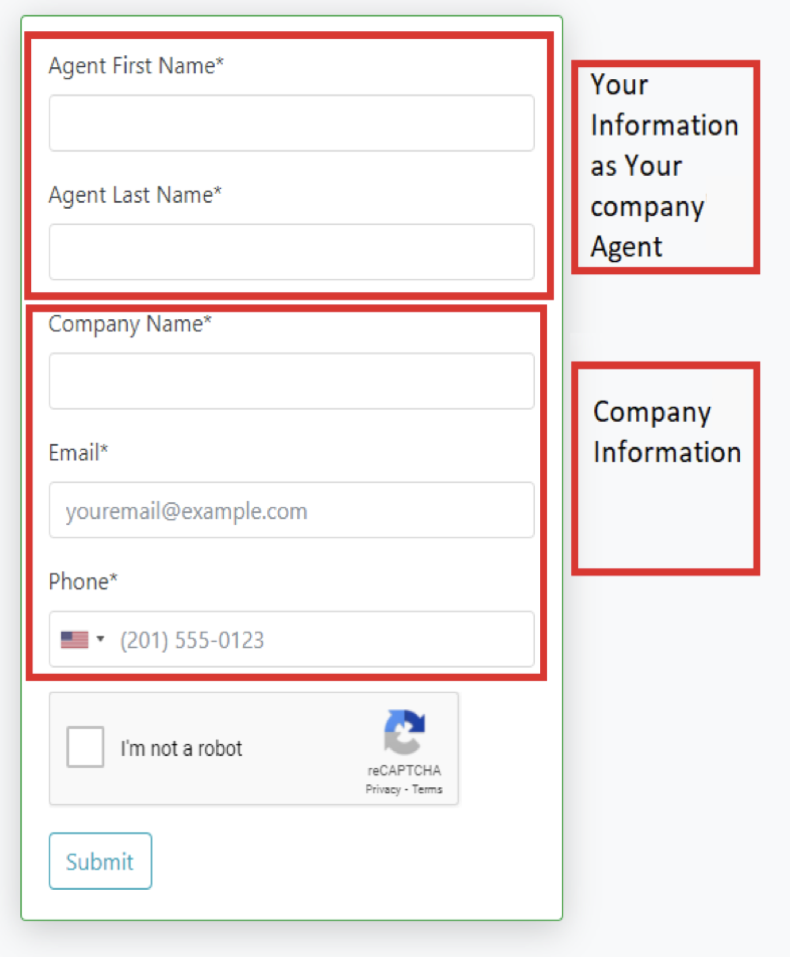

If you are logging in your profile for the first time, you are requested to provide your profile with necessary information as follows. In addition, everybody has access to their profile via “Dashboard/Profile”.

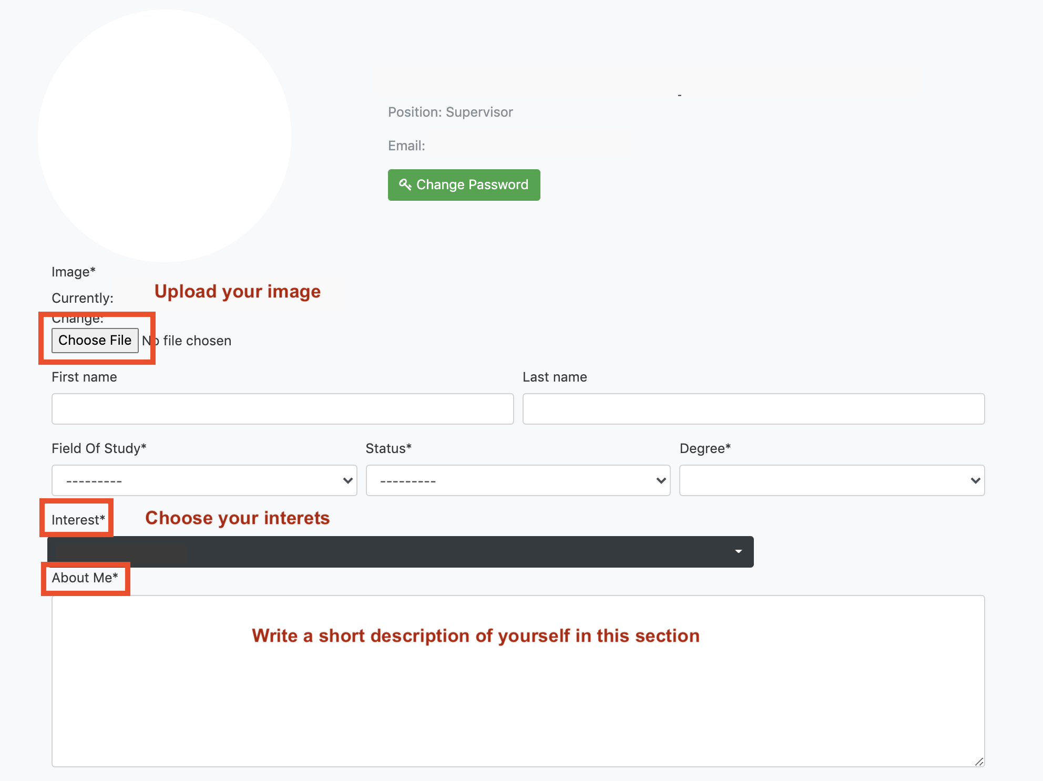

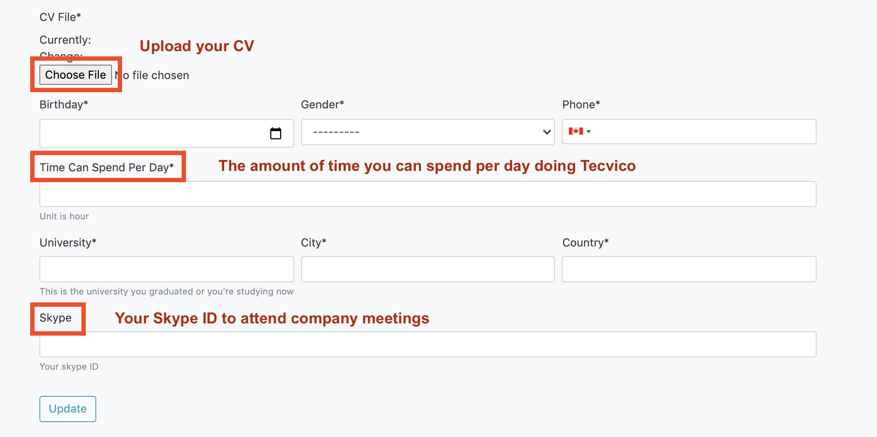

### **Choose your Experience Badges**

Your are requested to determine your badges in your “Dashboard” as follows.

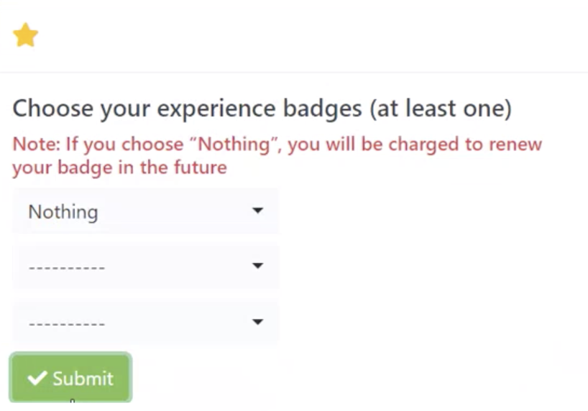

If you want to apply for Research projects, you must specify your Experience Badges. The supervisor will consider your application to participate in the project based on your selected badges and how well it aligns with the required skills in the project. You choose these badges according to the skills you have.

In addition, after the project is done, supervisor will give new badges to you or update badge scores.

Moreover, if you would like to add some badge to your profile, you must request. The company will charge you and then determining an interviewer to specify your badge. The meeting will be as online.

Based on your efficiency, the supervisor will add or deduct in score of your badge. In fact, this action causes an automatic system to tune badges. Badges also play a crucial role in participation into Competition and Industry projects.

### 

### **Go through the projects and find the ones that you find interesting**

After completing your profile, from the “Projects” section in your “Dashboard”, you can see the types of projects available in the company and select the projects that are closest to your research field and interests as follow:

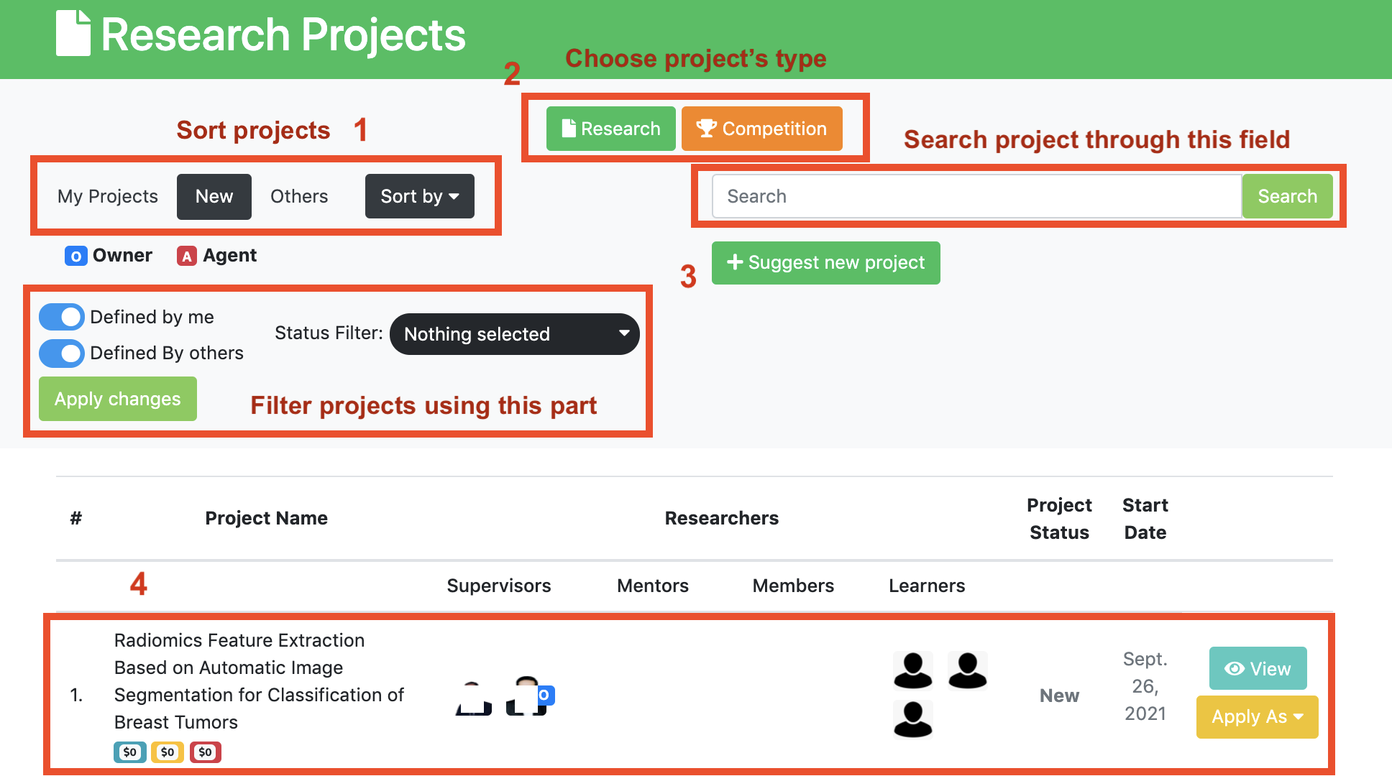

[1] -> This page has three tabs: My Projects, New and Others.

In the “New” tab, you can see all the projects that are new and haven’t started yet.

[2] -> You can also select a project type to see projects in each field. (Research, Industry, Competition)

[3] -> At the top of this page, you can search for a project or filter projects using filters.

[4] -> In the end, you can find the project you want among the projects and apply for it.

### 

### **Increase in your credit**

Balance is the amount of currency you have in your account.

You can see your balance in your “Dashboard”, at the top right of the page.

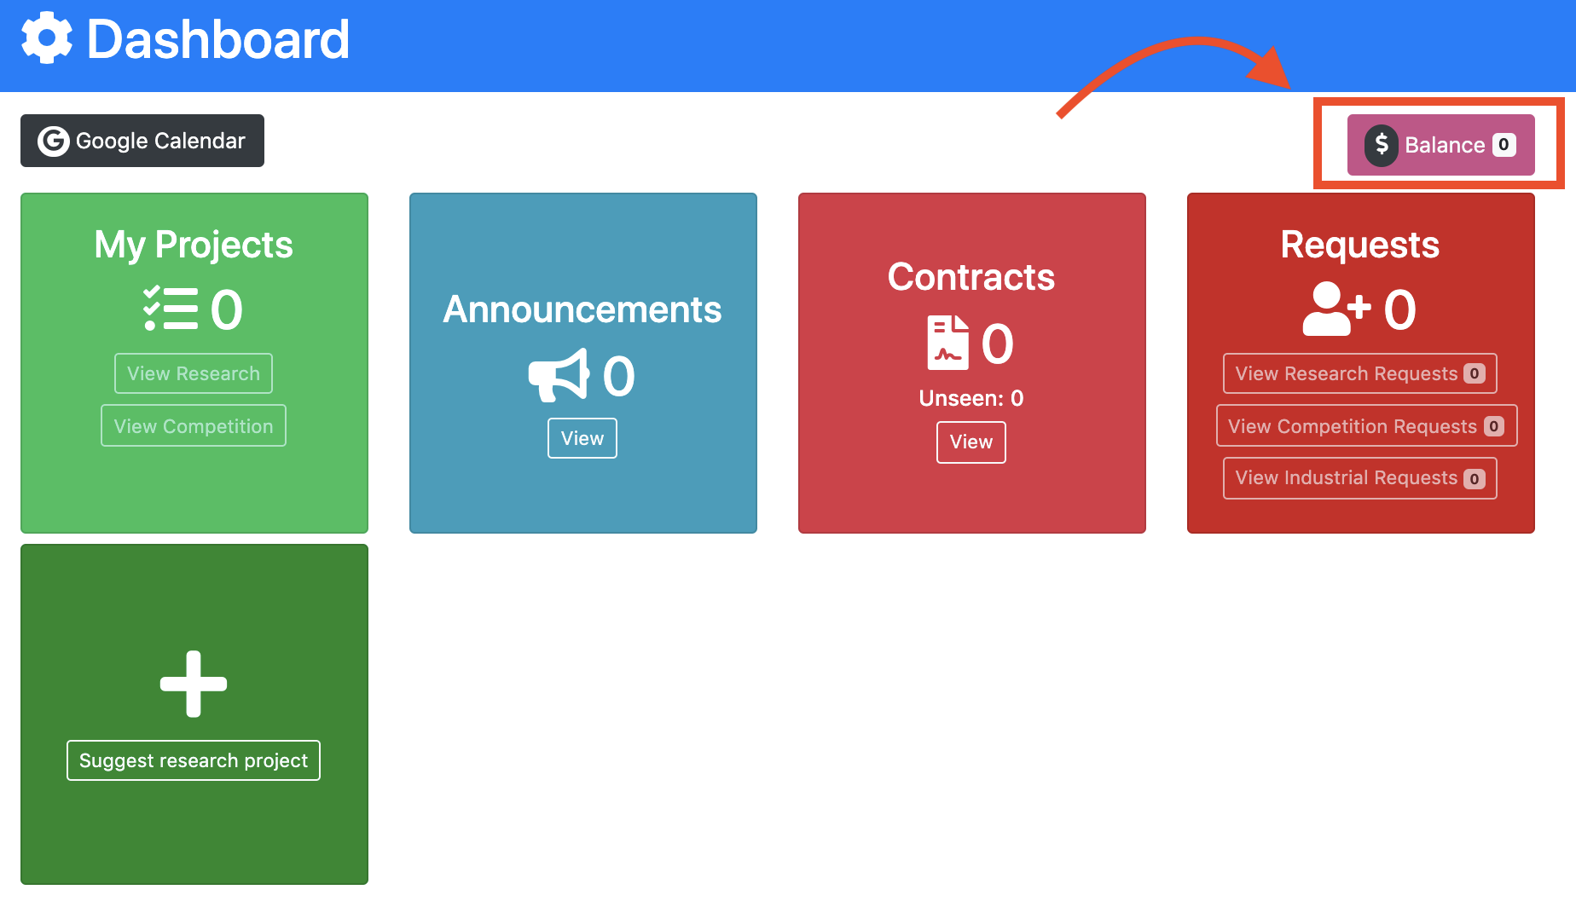

You can increase in your balance by clicking on it and adding the amount that you need to it. You would be redirected to another page that you first enter the amount, choose one of the payment methods (Stripe/Paypal), and then do the checkout as follows.

Note: Everybody is able to apply for a specific project if they have an enough balance.

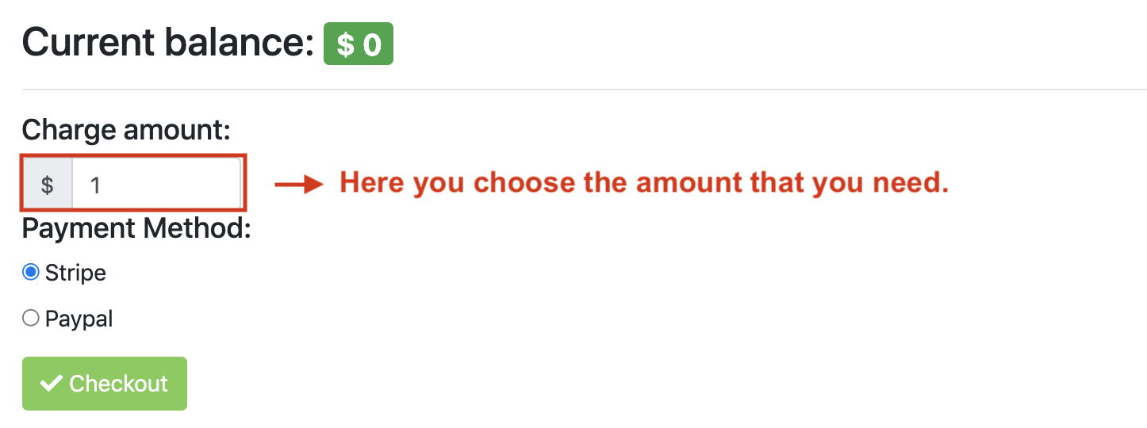

### **Apply for the projects**

If you would like to participate in the project, just click the “Apply” button of the project you want and choose your role you want to be in the project. The result of your request will be announced via Email or a notification in your profile via the main supervisor..

You can apply for projects as your role or the roles that fall under your category. For example, if your role is mentor, you can apply for projects as Mentor, Member or Learner.

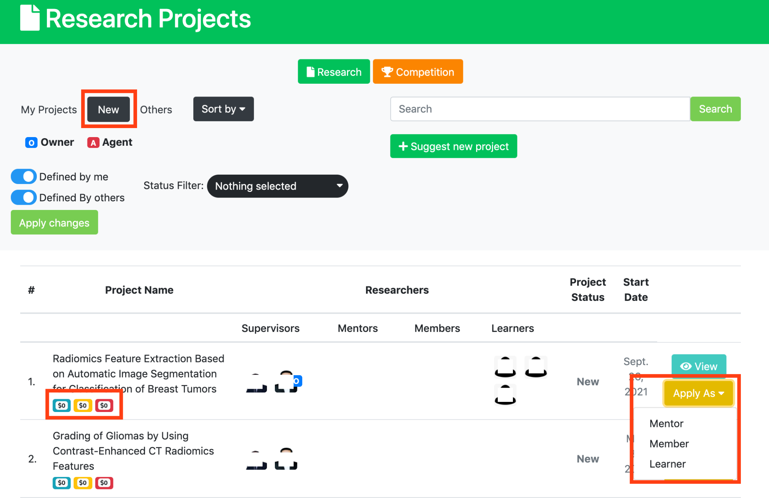

# **Responsibility Fee**



The 3 colored boxes under the name of each project are the amount that is required to enter the project, which is called “Responsibility Fee” and each role has different responsibility fee. Amount of responsibility fee for each role directly depends on importance of position in project. The blue box is for Mentor, the yellow box is for Member and the red box is for Learner.

When you apply for a project, the responsibility fee will temporarily be deducted from your wallet and blocked. If your application is approved by supervisor, the responsibility fee will permanently be deducted from your balance. In contrast, if your application is rejected, the responsibility fee will surely return to your wallet. If you don’t have enough balance which is required to apply for a project, you are not able to apply for it. . Thus, you can increase in your balance as much as you need and then apply for the project.

Sometimes a supervisor or mentor of a project wants you to be a part of them and send you a request to join them, you can manage these invitations for joining projects in your “Requests“ section in your Dashboard.

Here you can either accept or reject each of them.

You can find more information about the project you’ve been invited to, by clicking on “View Project details”.

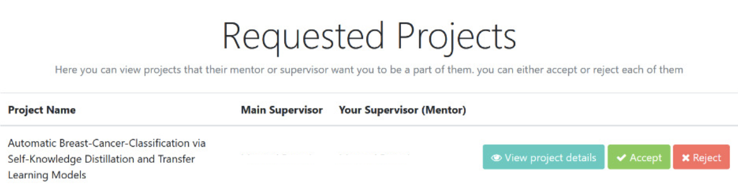

### **Sign the contract**

If your application to participate in the project has been approved by main supervisor, a contract is sent to you and is accessible through your “Contracts” section in Dashboard. The member/learner must read and sign the contract. The member/learner must then upload the signed contract. Next that, the director team will check and then s/he will be accepted as member/learner. The below figure show where the member/learner can find the contract.

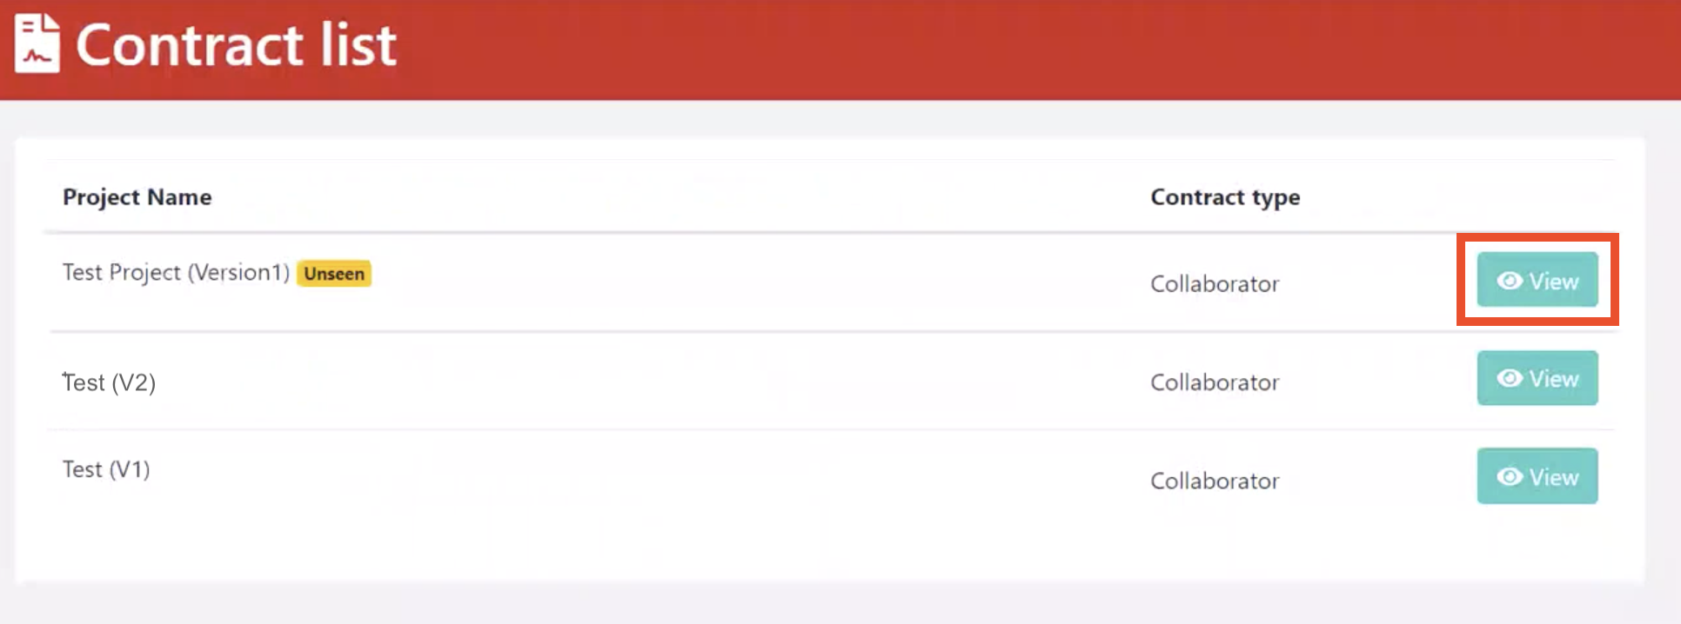

After clicking on “View”, you will enter the below page. From “View Contract” you should open the contract and then reading, downloading as PDF, and signing. In the end, you must upload the signed contract and then press Submit button as follows

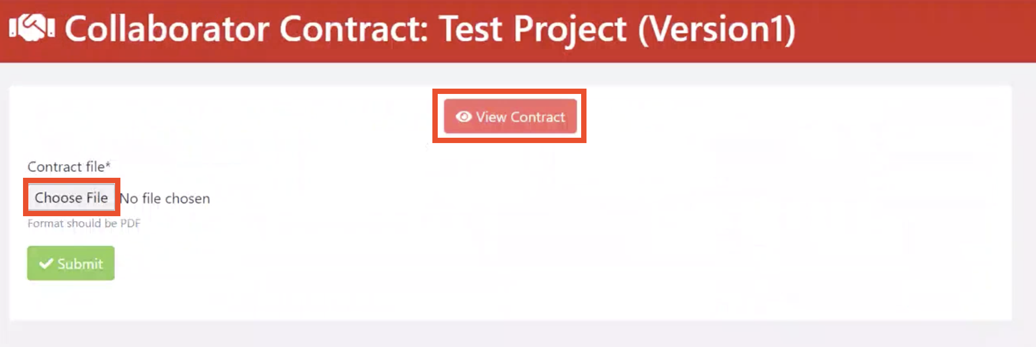

After that, you can see your submitted contract as follows.

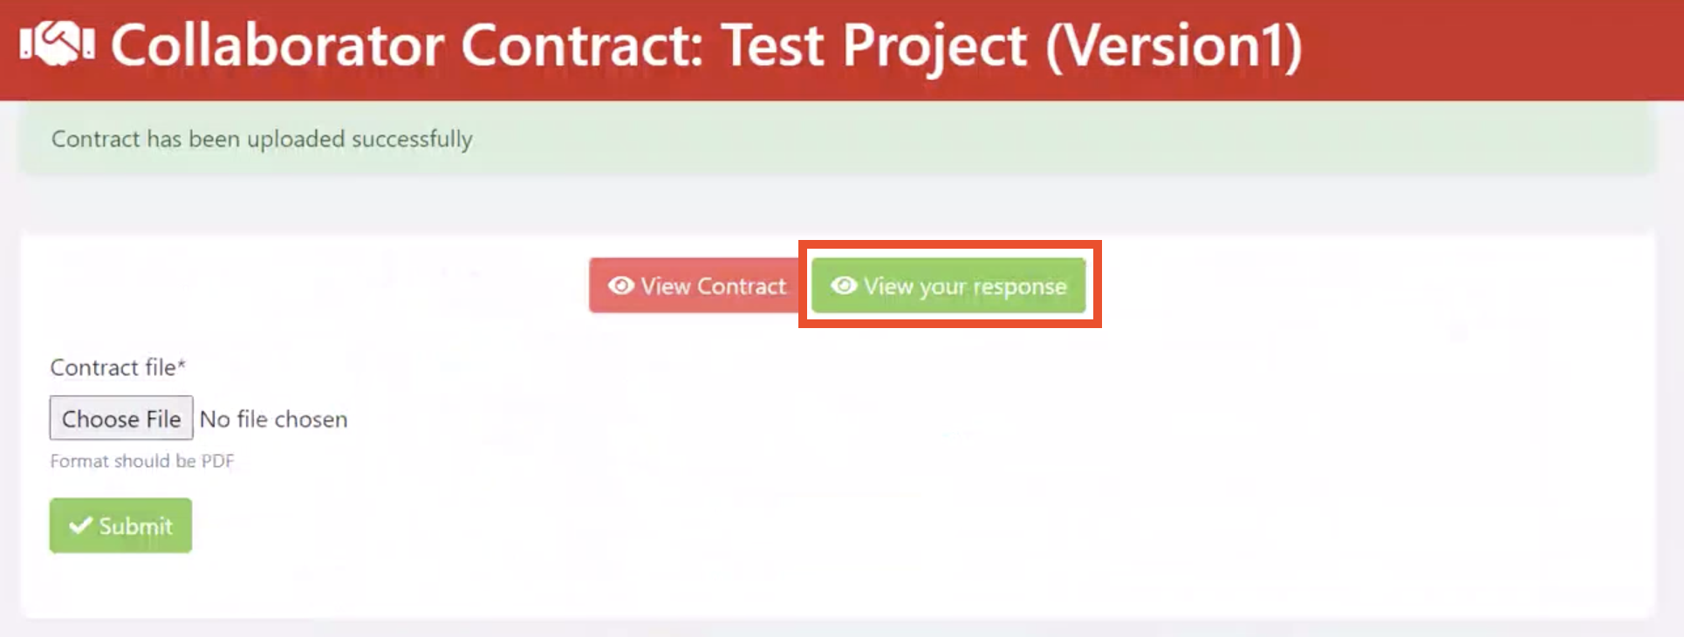

### **Check the meeting time**

Every project that starts, for better interaction of people, a meeting is held during the week to review the progress of the project.

The Projects in which you participate, you can see the information of the meetings in the “My projects” page under the name of each project.

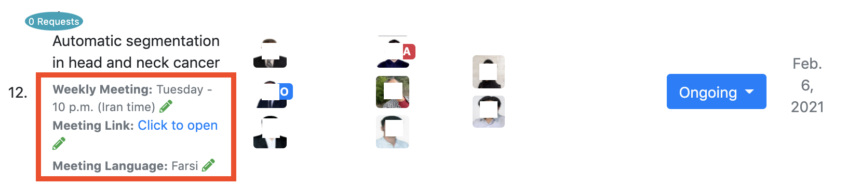

Attendance at these meetings is mandatory and the supervisor checks and records the presence of individuals.

### **Check tasks that assign from supervisor**

After entering the project, the supervisor will assign tasks to you and you must complete them before the deadline.

you can see your tasks in My project page in your Dashboard.